SCHOOL OF COMPUTER SCIENCE AND ARTIFICIAL INTELLIGENCE |  |  |  |  | DEPARTMENT OF COMPUTER SCIENCE ENGINEERING
Program Name: B. Tech |  |  |  | Assignment Type: Lab |  |  | Academic Year:2025-2026
Course Coordinator Name |  |  |  | Venkataramana Veeramsetty
Instructor(s) Name |  |  |  | Dr. V. Venkataramana (Co-ordinator)  Dr. T. Sampath Kumar  Dr. Pramoda Patro  Dr. Brij Kishor Tiwari  Dr.J.Ravichander  Dr. Mohammand Ali Shaik  Dr. Anirodh Kumar  Mr. S.Naresh Kumar  Dr. RAJESH VELPULA  Mr. Kundhan Kumar  Ms. Ch.Rajitha  Mr. M Prakash  Mr. B.Raju  Intern 1 (Dharma teja)  Intern 2 (Sai Prasad)  Intern 3 (Sowmya)  NS_2 ( Mounika)
Course Code |  |  | 24CS002PC215 | Course Title |  | AI Assisted Coding
Year/Sem |  |  | II/I | Regulation |  | R24
Date and Day  of Assignment |  |  | Week9 - WednesDay | Time(s)
Duration |  |  | 2 Hours | Applicable to  Batches
AssignmentNumber:17.3(Present assignment number)/24(Total number of assignments)
 | Q.No. | Question |  |  |  |  |  | Expected Time  to complete
 | 1 | Lab 17 – AI for Data Processing: Data Cleaning and Preprocessing Scripts  Lab Objectives:  - Learn how to clean raw datasets using AI-assisted Python scripting.  - Apply preprocessing techniques such as handling missing values, encoding categorical data, and normalization.  - Automate repetitive data-cleaning tasks with AI-generated code.  - Understand how preprocessing impacts model performance.  Task 1 – Social Media Data Cleaning  Task: Clean raw social media posts dataset.  Instructions:  - Remove stopwords, punctuation, and special symbols from post text.  - Handle missing values in likes and shares columns.  - Convert timestamp to datetime and extract features (hour, weekday).  - Detect and remove spam/duplicate posts.  Expected Output: A cleaned dataset with structured features for sentiment/engagement analysis.  Task 2 – Financial Data Preprocessing  Task: Preprocess a stock market dataset.  Instructions:  - Handle missing values in closing_price and volume.  - Create lag features (1-day, 7-day returns).  - Normalize volume column using log-scaling.  - Detect outliers in closing_price using IQR method.  Expected Output: A time-series dataset ready for forecasting models.  Task 3 – IoT Sensor Data Preparation  Task: Clean and preprocess IoT temperature and humidity logs.  Instructions:  - Handle missing values using forward fill.  - Remove sensor drift (apply rolling mean).  - Normalize readings using standard scaling.  - Encode categorical sensor IDs.  Expected Output: A structured dataset optimized for anomaly detection.  Task 4 – Real-Time Application: Movie Reviews Data Cleaning  Task: A streaming platform wants to analyze customer reviews.  Instructions:  - Standardize text (lowercase, remove HTML tags).  - Tokenize and encode reviews using AI-assisted methods (TF-IDF or embeddings).  - Handle missing ratings (fill with median).  - Normalize ratings (0–10 → 0–1 scale).  - Generate a before vs after summary report.  Expected Output: A cleaned dataset ready for sentiment classification.  ✅ Deliverables (For All Tasks)  - AI-generated prompts for code and test case generation.  - At least 3 assert test cases for each task.  - AI-generated initial code and execution screenshots.  - Analysis of whether code passes all tests.  - Improved final version with inline comments and explanations.  - Compiled report (Word/PDF) with prompts, test cases, assertions, code, and output. |  |  |  |  |  | Week9 - Monday

Task 1 – Social Media Data Cleaning
Task: Clean raw social media posts dataset.
Instructions:
- Remove stopwords, punctuation, and special symbols from post text.
- Handle missing values in likes and shares columns.
- Convert timestamp to datetime and extract features (hour, weekday).
- Detect and remove spam/duplicate posts.
Expected Output: A cleaned dataset with structured features for sentiment/engagement analysis.

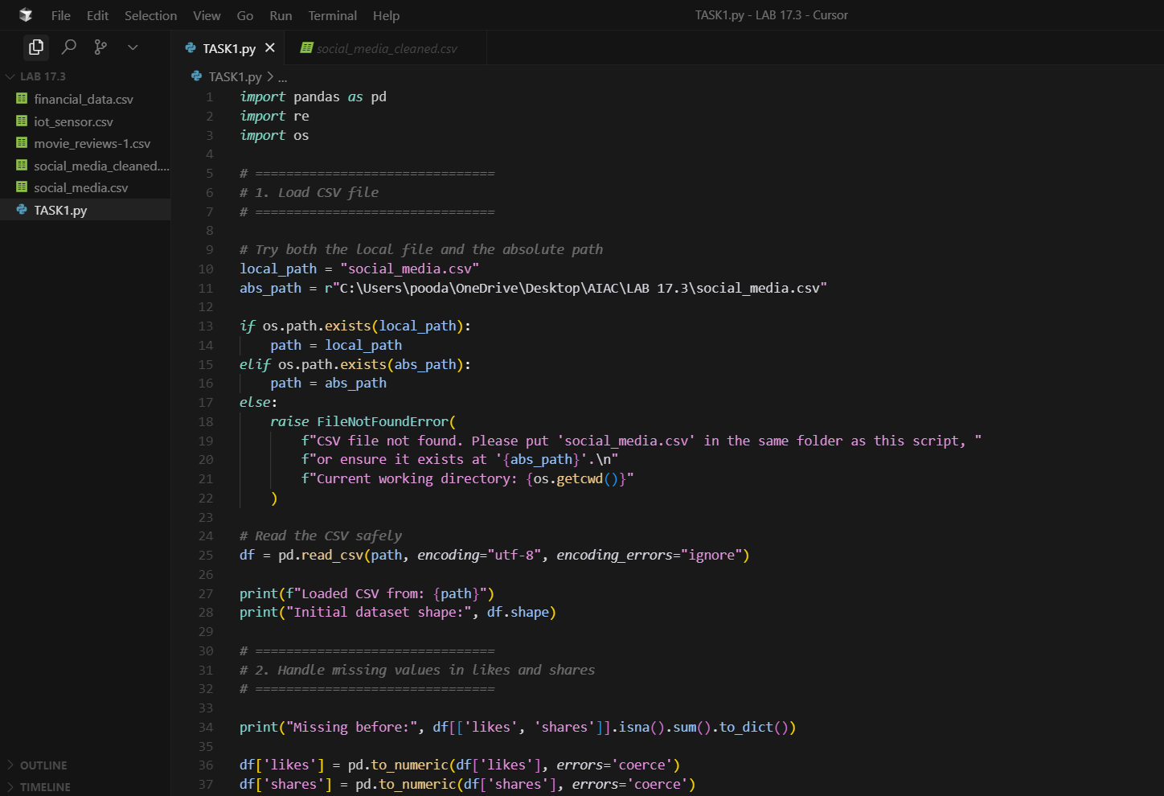

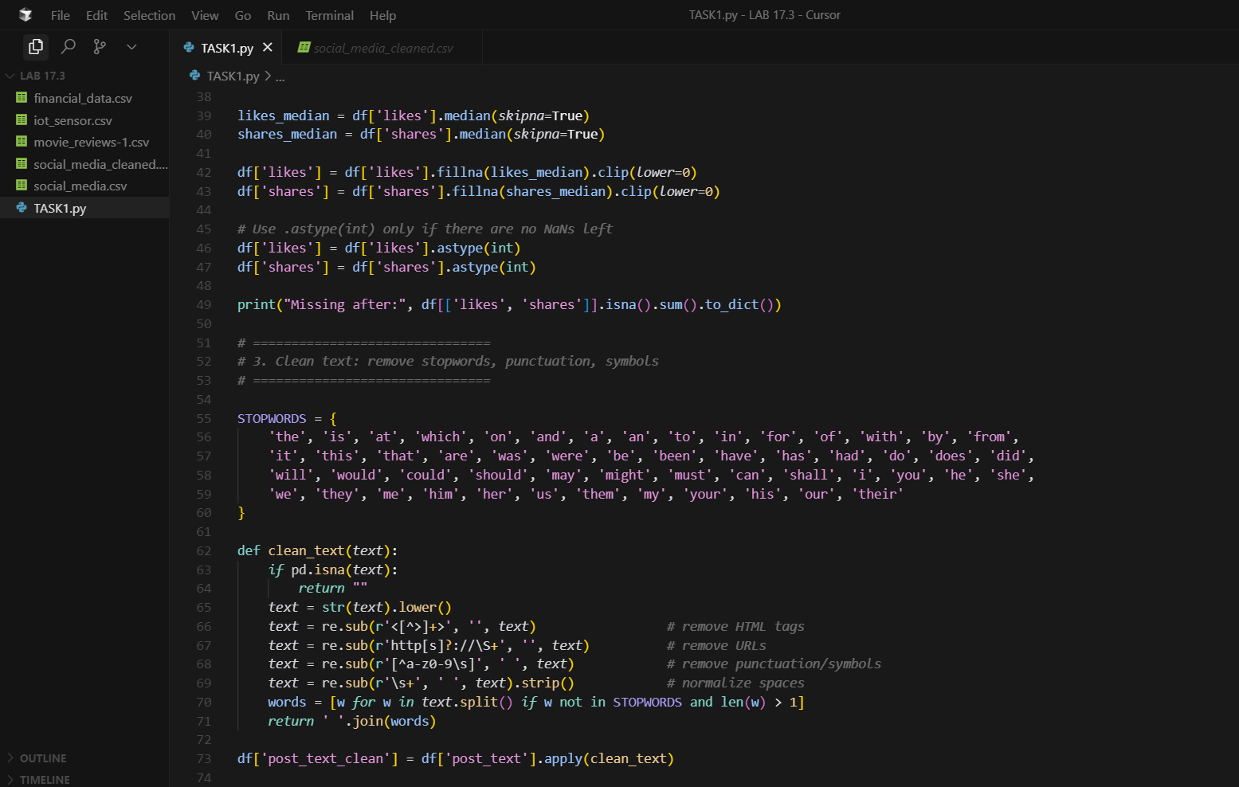

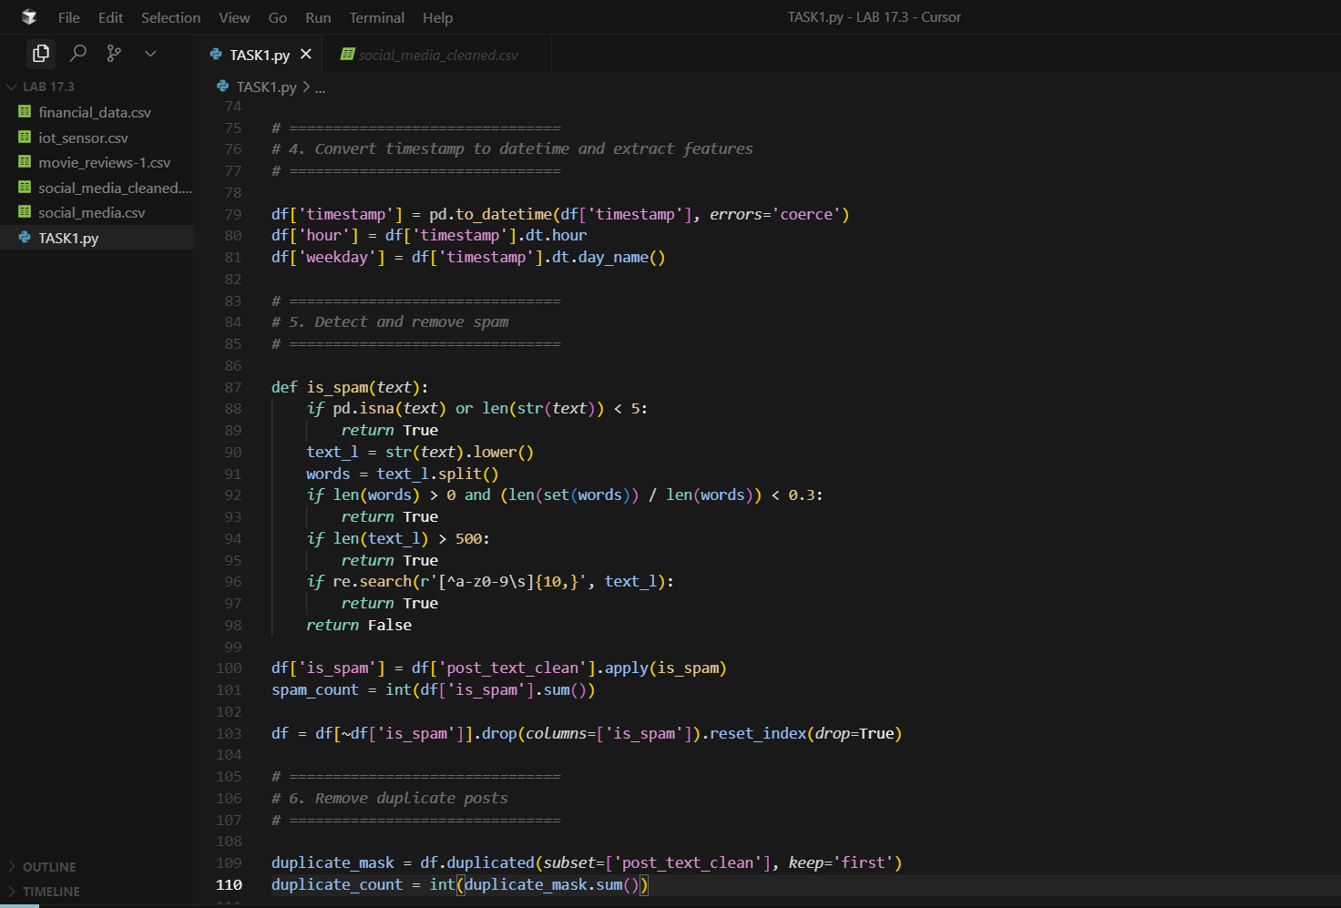

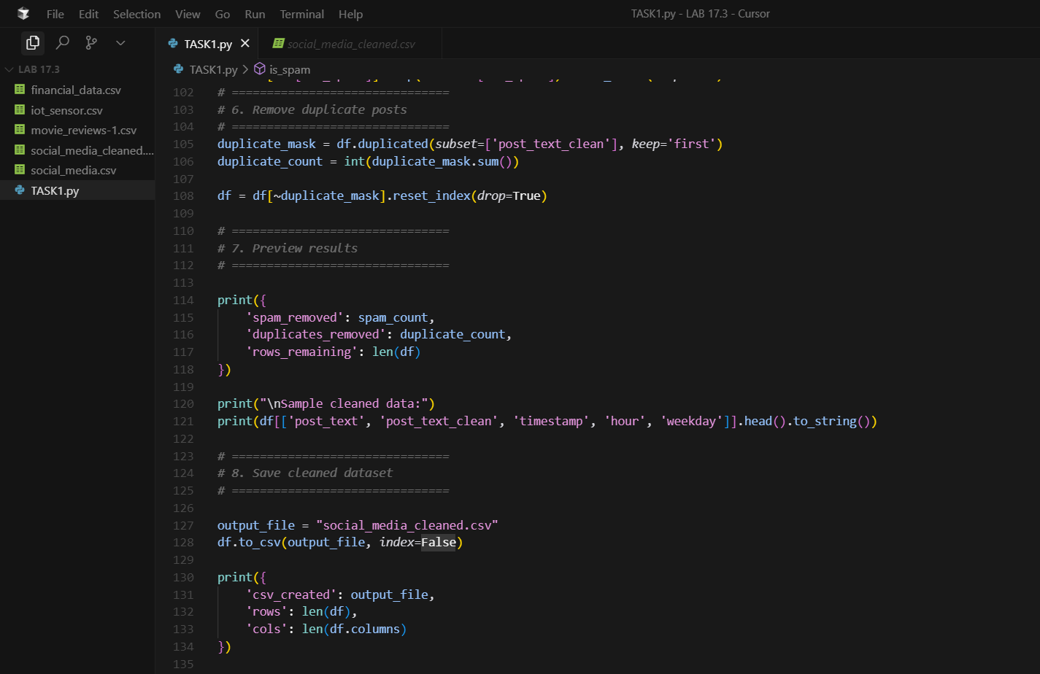

OUTPUT:
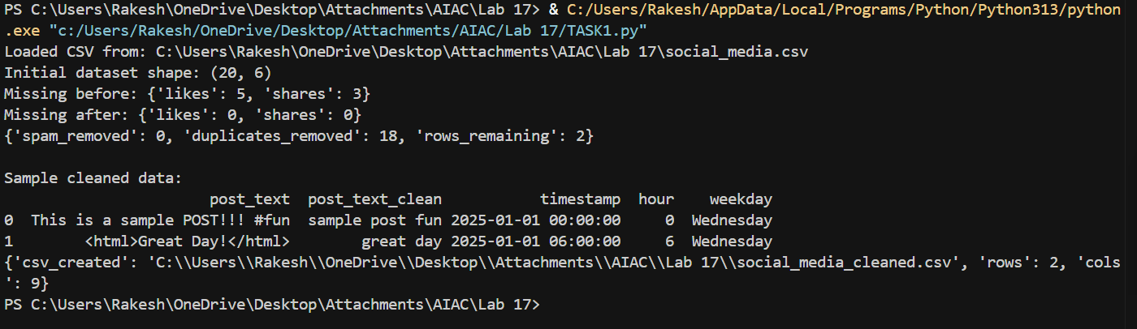

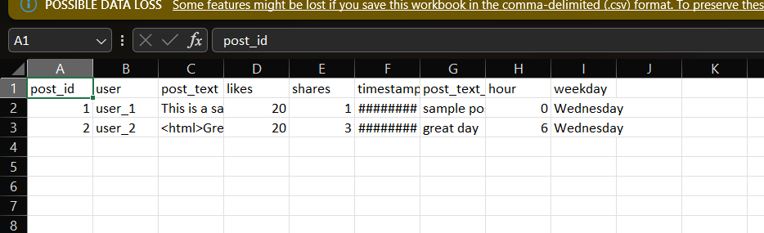

Task 2 – Financial Data Preprocessing
Task: Preprocess a stock market dataset.
Instructions:
- Handle missing values in closing_price and volume.
- Create lag features (1-day, 7-day returns).
- Normalize volume column using log-scaling.
- Detect outliers in closing_price using IQR method.
Expected Output: A time-series dataset ready for forecasting models.

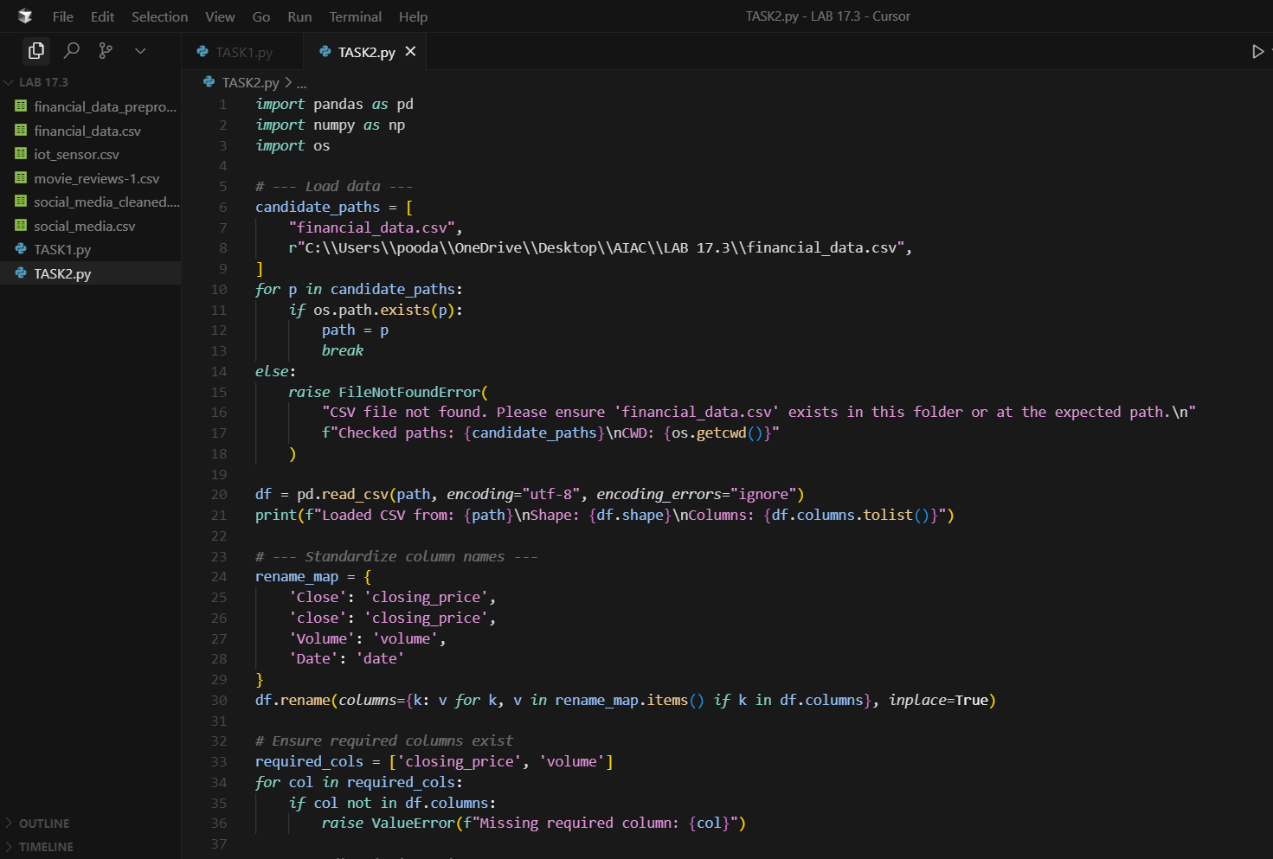
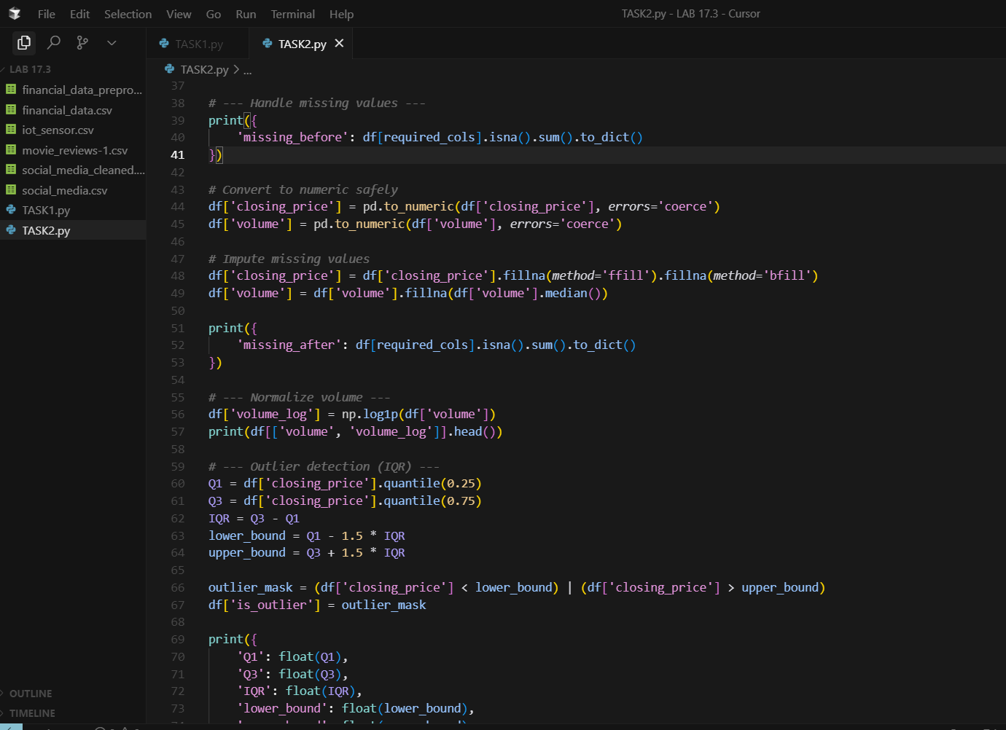

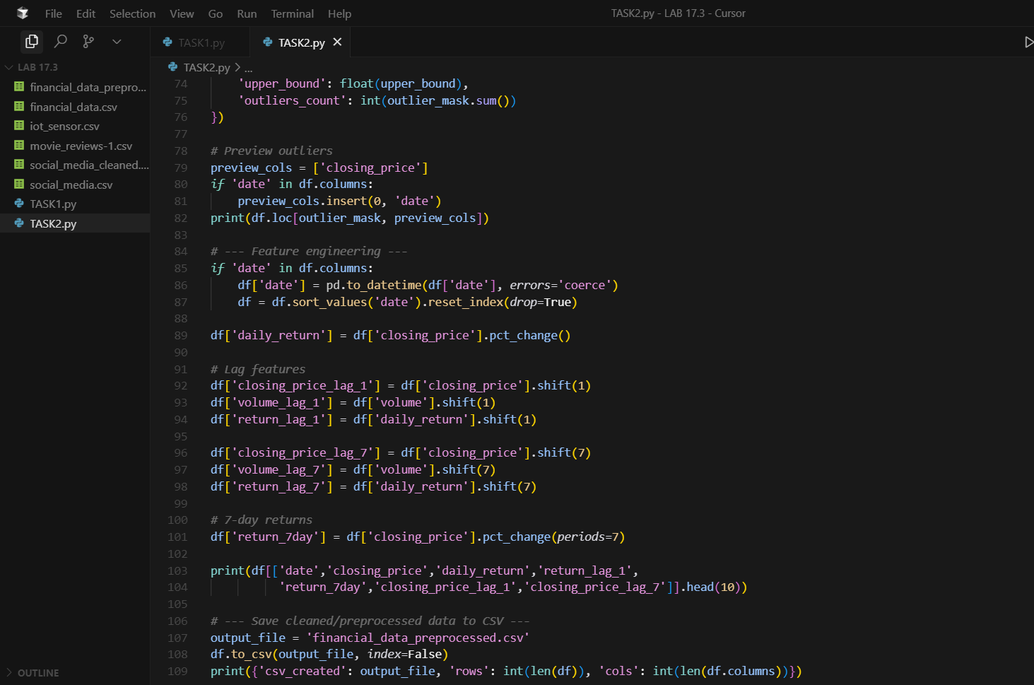

OUTPUT :

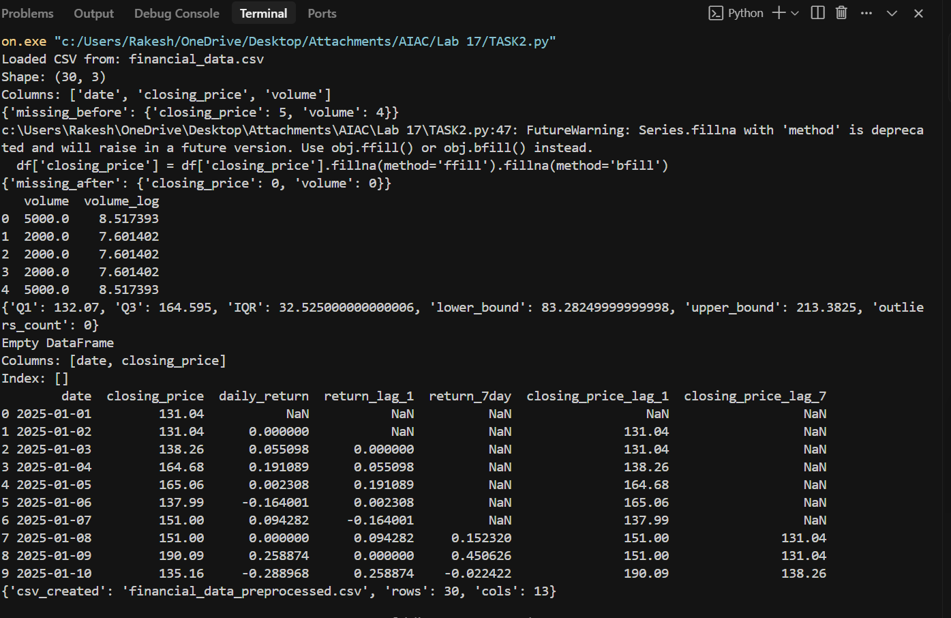

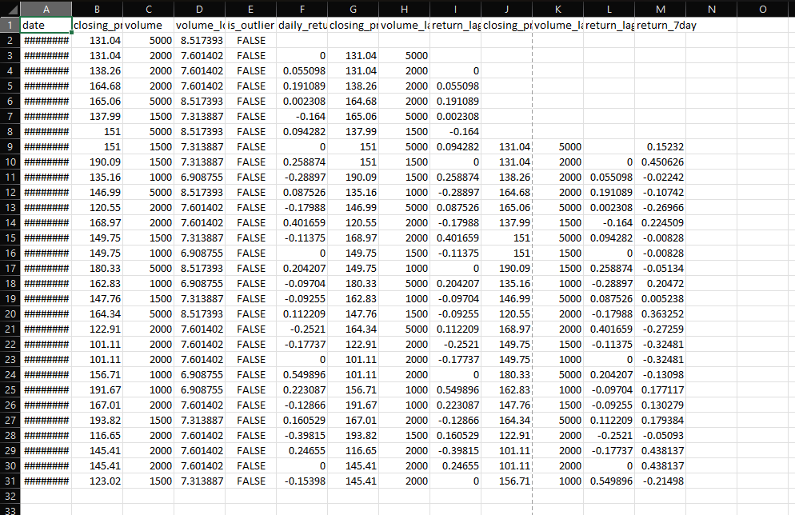

Task 3 – IoT Sensor Data Preparation
Task: Clean and preprocess IoT temperature and humidity logs.
Instructions:
- Handle missing values using forward fill.
- Remove sensor drift (apply rolling mean).
- Normalize readings using standard scaling.
- Encode categorical sensor IDs.
Expected Output: A structured dataset optimized for anomaly detection.

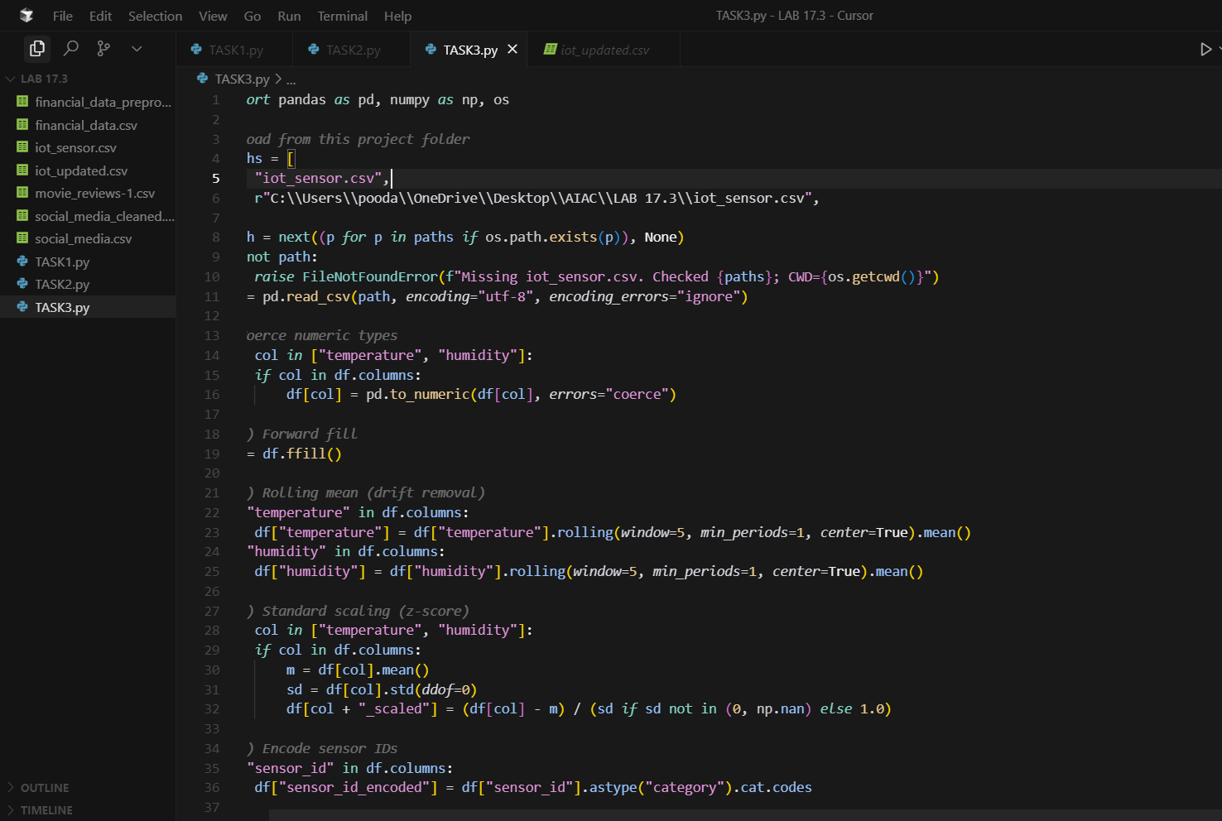

OUTPUT :
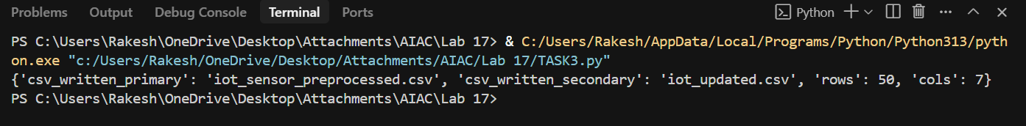
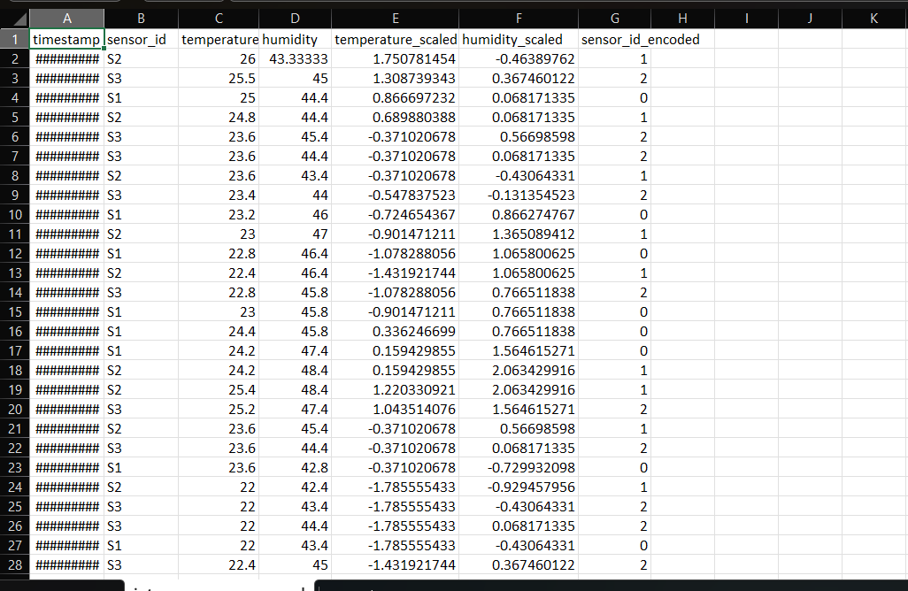

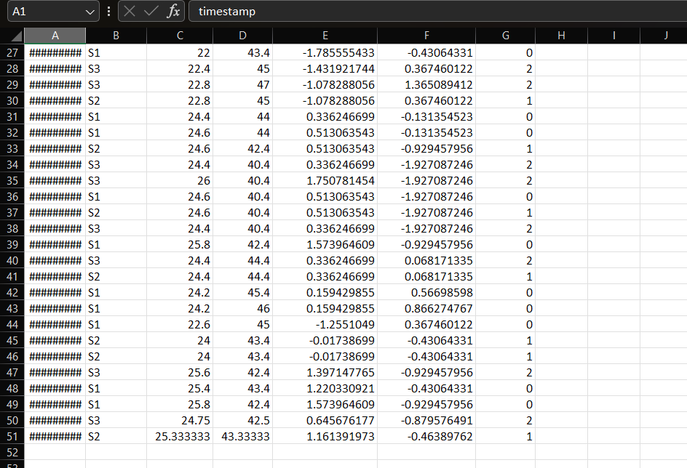

Task 4 – Real-Time Application: Movie Reviews Data Cleaning
Task: A streaming platform wants to analyze customer reviews.
Instructions:
- Standardize text (lowercase, remove HTML tags).
- Tokenize and encode reviews using AI-assisted methods (TF-IDF or embeddings).
- Handle missing ratings (fill with median).
- Normalize ratings (0–10 → 0–1 scale).
- Generate a before vs after summary report.
Expected Output: A cleaned dataset ready for sentiment classification.
✅ Deliverables (For All Tasks)
- AI-generated prompts for code and test case generation.
- At least 3 assert test cases for each task.
- AI-generated initial code and execution screenshots.
- Analysis of whether code passes all tests.
- Improved final version with inline comments and explanations.
Compiled report (Word/PDF) with prompts, test cases, assertions, code, and output.

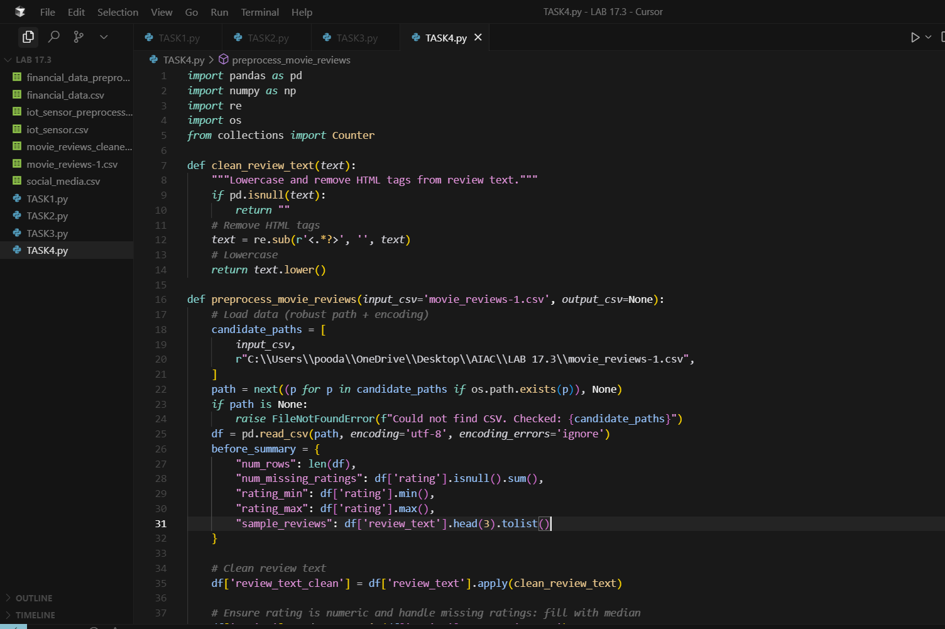

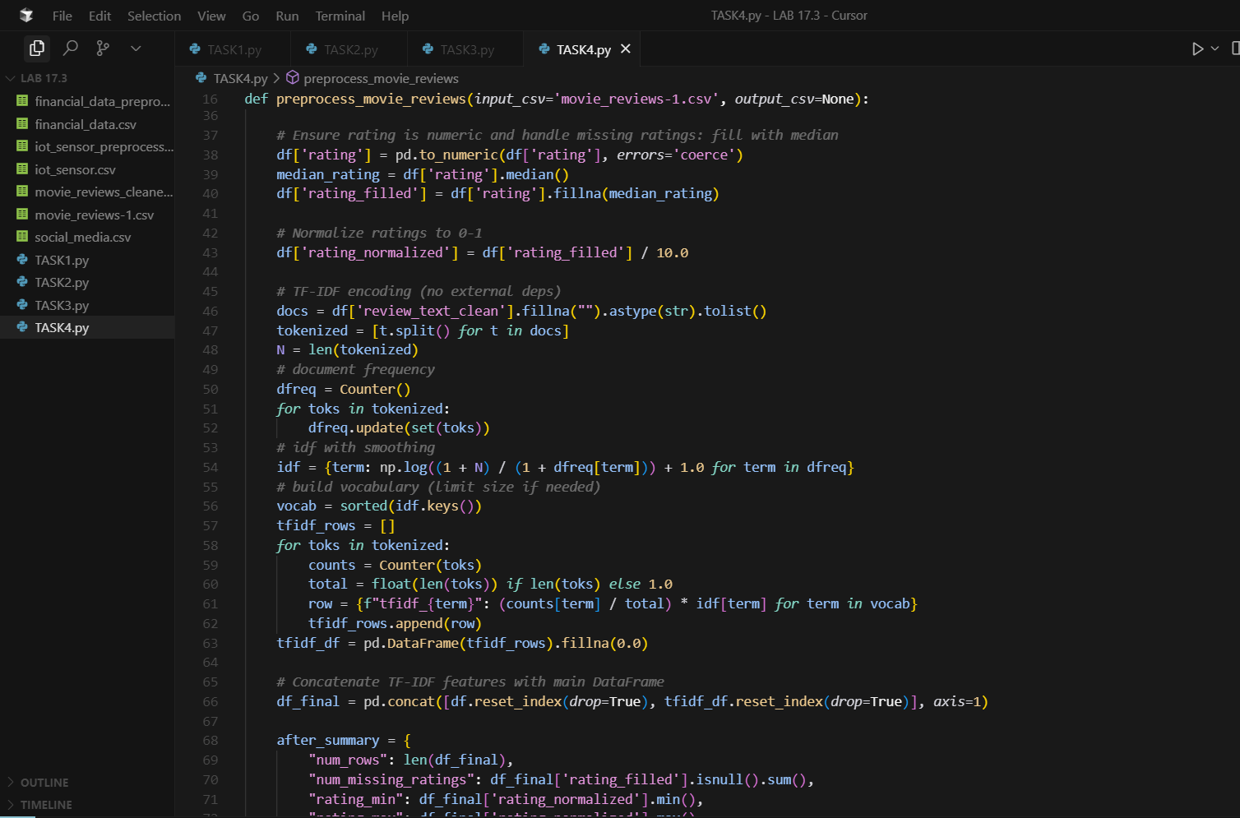

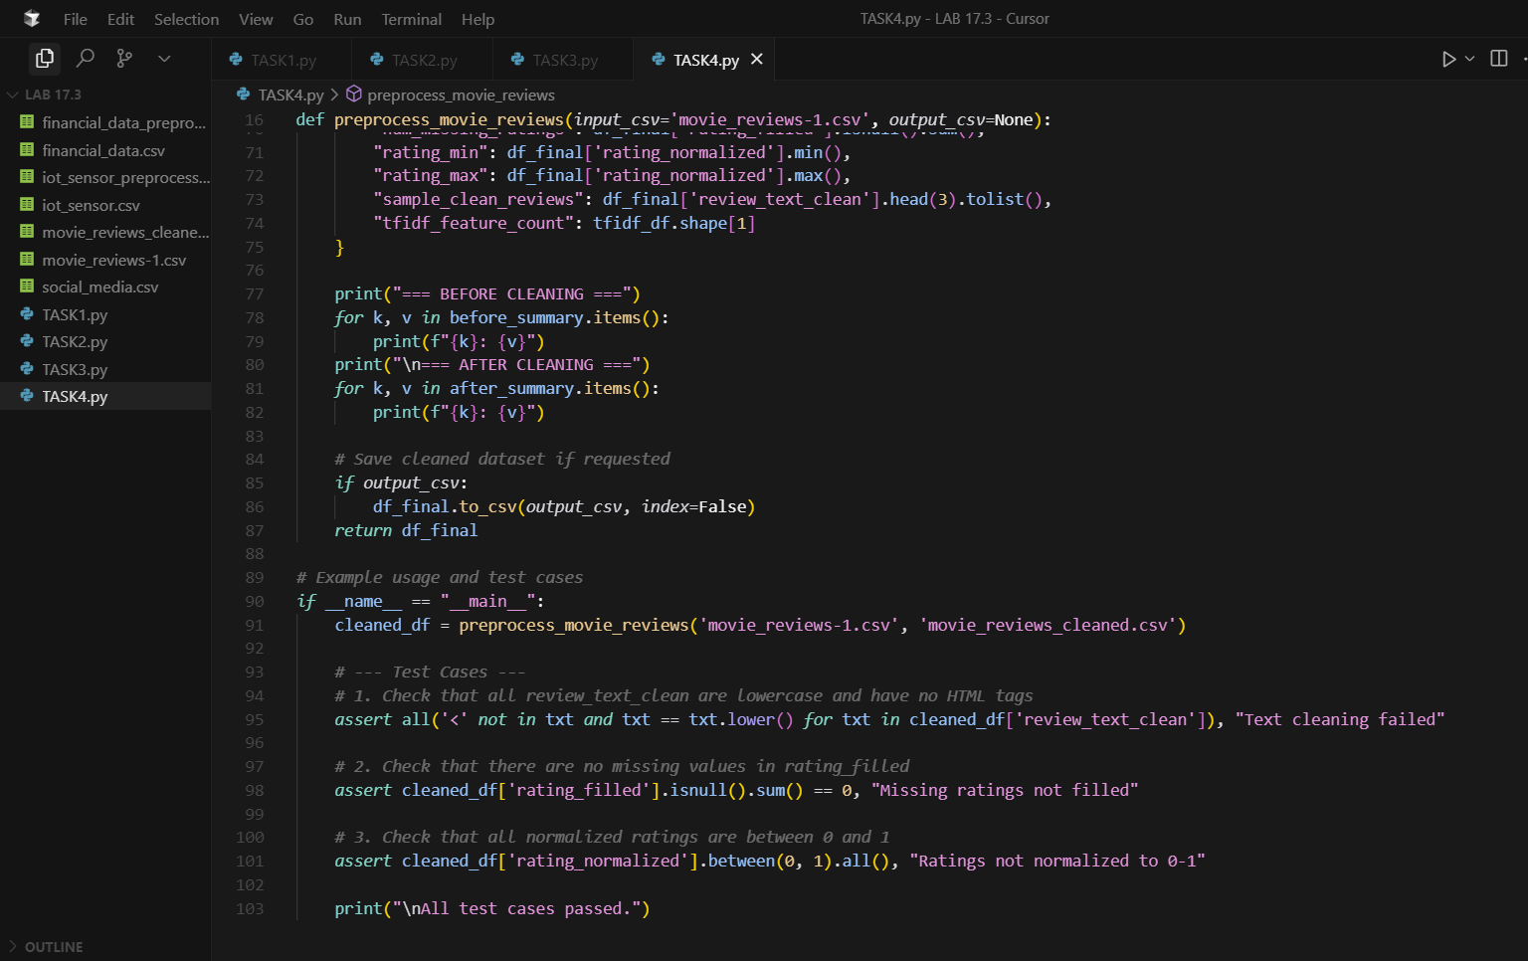

OUTPUT :

